
GUERRA
This means War . . .

Evitare Guerra Cazzata Guerra

All work Copyright ©2003 NVL and the Guildhall at SMU

Tuesday, July 28, 2026Table of Contents
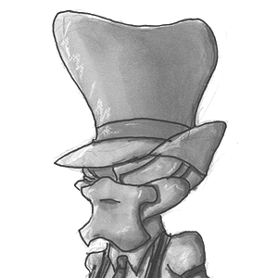
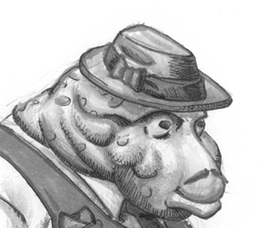
GUERRA 1
Game Overview 4
Guerra Game Overview 4
Cazzata Guerra 4
Evitare Guerra 4
Gameplay Details 5
Cazzata 5
Scoring 5
Evitare 6
Scoring 6
Game Mechanics 7
Camera 7
GUI 7
Pre-Game Interface 7
In-Game GUI 7
Pausing 8
Control Summary 8
The Game World 10
Look and Feel 10
Key Features 10
The World Layout 10
Evitare 10
Cazzata 11
Characters 12
Halfrunts 12
Zaphods 12
Weapons 13
Conk Launcher: 13
Tommy Gun: 13
Sniper Rifle: 13
Conk Gun: 14
Gauntlet: 14
Shotgun: 14
Ball Launcher: 14
Music and Sound Effects 15
Target Audience 15
Marketing 15
Technical Specifications 15
Code Assets 15
AI 16
Tools Used 16
System Requirements 16
Minimum System Requirements – PC. 16
Multiplayer Requirements. 17
Minimum System Requirements – MAC. 17
Asset List 18
Art Assets 18
Characters 18
Environments / World Objects 18
3D Level Objects 18
Environmental Textures 18
Weapons 19
Development Plan 20
Documentation: 20
Art Development Plan: 20
Keith & Kevin 20
Level Design Development Plan: 21
John B. 21
Programming Development Plan: 21
Brian 21
Jon 22
Nick 23
Mike 23

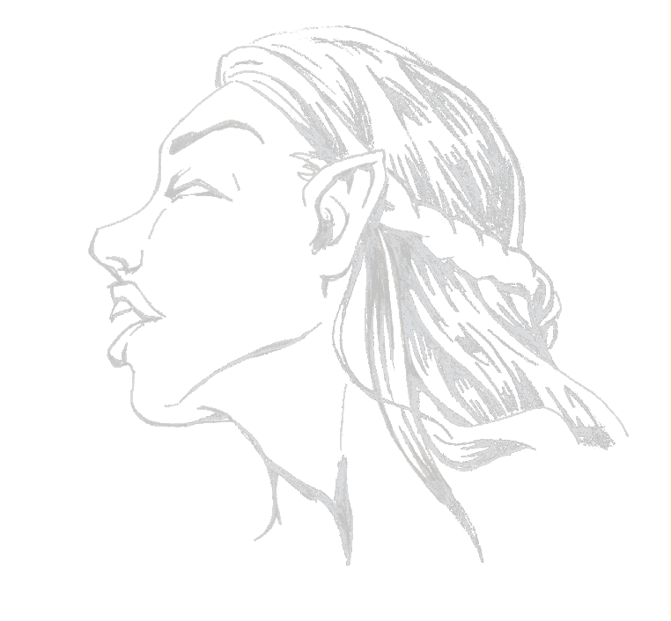

Game Overview
Guerra is made up of two distinct modifications of the Quake III game. Cazzata Guerra is a team based game of “hide and go snipe.” Evitare Guerra can be either a free for all, or team dodge-ball game

Guerra Game Overview
-Guerra (n) war (on {or} against)
The world of Allupato is home to two different alien races. For the past several decades the Halfrunts and the Zaphods have been in a war with each other. These two species have a strange obsession with the entertainment of a small, insignificant world … Earth. On the world of Allupato, the citizens have modeled their cities and behavior on Earth’s mobster movies. This war has been both open and covert throughout the years. They compete in all aspects of life like economics, politics and sports.

Cazzata Guerra
-Cazzata (vulgar) bloody nonsense
Cazzata is the term used when the alien’s battles come out into the open and a violent turf war ensues. Each “family” is out to kill their opponents’ Don while trying to protect their own. The two alien races have a different outlook on how this task should be undertaken. The Halfrunts use the brute force approach, arming themselves with a rapid-fire tommy gun. The Zaphods use their superior vision to engage in a long-range assault using sniper rifles. Once one of the families’ targets has been ‘rubbed out’ a new Don will emerge from the ranks and the battle begins afresh.

Evitare Guerra
-Evitare (vt) to dodge; to evade
Evitare is the popular alien interpretation of the classic Earth sport of dodge ball. Because of its popularity, the two species have decided to invest huge amounts of money and family members into the sport. Fortunes and honor are gained and lost on each round of this fast-paced game. Not being satisfied with just tossing around a red rubber ball, the Alluputians decided to make a few modifications. The first thing they did was to add weapons to the game. If you are frozen by a weapon and an enemy hits you with the ball you are shrunk. While small you can still affect the game but different ways. The object of the game is to freeze the opponents with the tommy gun, and then hit them with the ball to shrink them. Once all of the opponents are shrunk the team or person left regular size is the winner.

Gameplay Details

Cazzata
This is a strategic team based first person shooter/ hide and go snipe level. Each team must make their way to the other team’s base and kill the other team’s boss. The teams can travel from rooftop to rooftop or travel the city streets. The boss is represented by a bot that resides on the top floor of each base. When the boss is killed, the team that made the kill is awarded points, the players return to their bases and the game continues. The game play takes place on the rooftops and the ground level of the city. The Zaphods carry a Conk Gun that shoots a concussion burst. They can point it at the ground, fire, and propel themselves into the air. Timed correctly, a double firing of this weapon can launch the player far into the heights of the city. This gun also repels opposing team members, knocking them across the map.
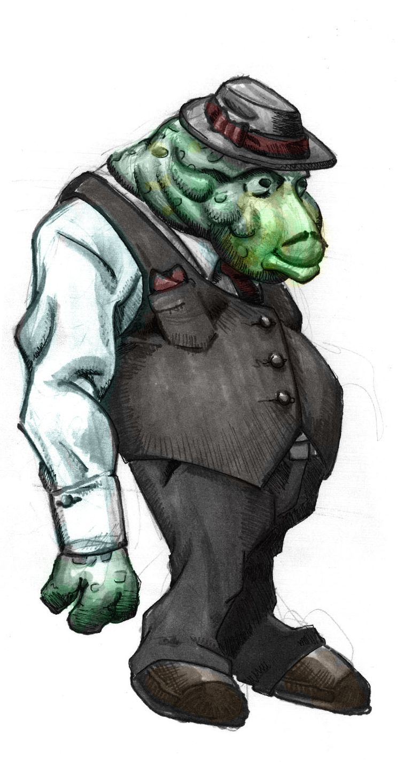
The Halfrunts are armed with a concussion grenade launching gun that can shoot the grenades up onto the rooftops and push the snipers out of their roosts. This will encourage the snipers to find good hiding spots and keep moving.
The Zaphods have the option to shoot the enemy boss at
long range from a rooftop or make their way into the
enemy base and shoot the boss up close. The Halfrunts
can try to shoot the enemy boss from a distance but
the tommy gun is better used up close. The bullets
scatter over distance. The Halfrunts should make their
way into the enemy base to shoot the boss. While the
Halfrunts don’t have a long range weapon, the
Zaphod's base has more than one entrance they can use
to reach the Don.

Scoring
For each kill a player get 1 point.
For assassinating the Don a player gets 10 points.
Each team gets one point per Don frag.
The scores carry over across rounds.

Evitare
The players start off with a gauntlet, a conk launcher, and a ball glove. The player always has the conk launcher and the gauntlet. The player can only hold one other weapon at a time. To pick up one, you must drop the other. The tommy gun and shotgun fire small ice crystals that will freeze you if you are hit enough times. The ball glove can be used to throw the ball at an opponent or pass it to your teammates.
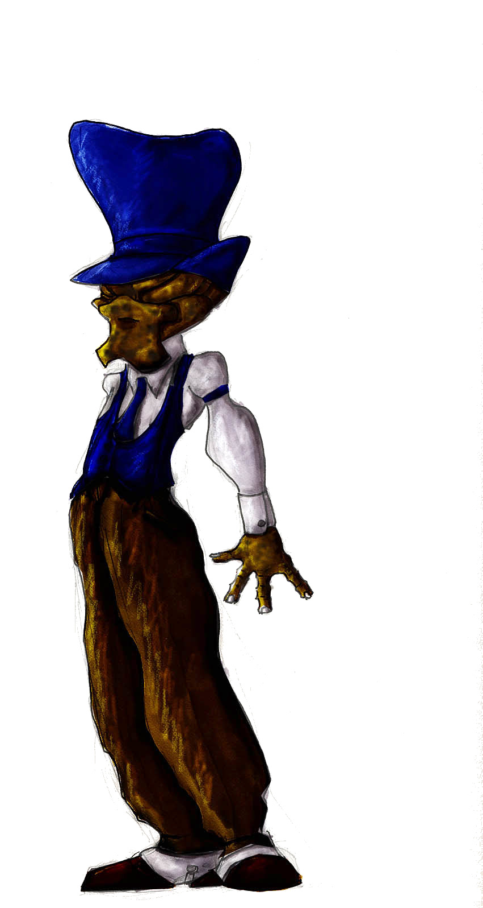
If a ball is thrown in a team game it is charged up with the team color, or yellow in a free for all game. If the ball hits a frozen person while charged (and they are not of the same team as the person who through the ball) they shrink. If the ball hits a team mate who is frozen they immediately thaw, and the ball is caught if they have a ball glove. If they do not, the ball bounces off. If the ball hits an opponent who is not frozen, the ball bounces off and does no damage at all but does cause a knockback. When a player picks up a tommy gun or shot gun, then the ball glove is lost and that weapon is gained. When a player gets shrunk
by the ball, they are forced into third person mode. They
move at three quarters the speed of the normal-sized players.
Their animation is sped up to reflect the relative difference
in speed to their height and to maintain consistency.
They do half damage to their opponents still larger than
them and full damage to players of their own size.
Players at normal size do full damage to the tiny people,
but they are much harder to hit because of their size.
If hit by the ball fired from an enemy, the small
player is squished, and will respawn.
The game will end with the shrinking
of all of one teams players.

Scoring
In Evitare, one score point is
awarded every timethat the player freezes
an opponent player. When a player throws
a ball and hits a frozen opponent player
causing him to shrink, that player is
awarded 10 points.
In the Free For All game mode, in
addition to the above rules, the last player
left who is big is awarded 100 points.

Game Mechanics
Guerra is a first-person (with bouts of third person envy), 3D shooter game that is created by modifying id software’s Quake III.

Camera

In the game, the player will be in control of their player character in a first person camera for the majority of the time. The only exception to this is in the Evitare game type when the player gets shrunk by the ball they become tiny and move to a third-person view.

GUI

Pre-Game Interface
The game will feature a new look to the interface once one of the mods is loaded. This will fit the visual style of the games. Each mod will have the standard options for playing the game, setup and exit. However, Single-player will be removed from the Cazzata Mod. An option to switch to the other mod will be available from the main screen as well. There will also be a Credits page.

In-Game GUI
The majority of the screen will be filled with the action within the game. A small portion of the screen in the lower areas will be taken up with indicators for health, ammo, which weapon you are currently using, and in the case of Evitare, how long you are frozen for.

Health: In the middle of the lower portion of the screen, a shrunken version of the player model’s head appears next to the number of health points the player currently has. The ‘healthy’ state for a player is 100 health points, but can go all the way up to 200 points if the player gets more health from powerups. The model head looks side to side at all times and grows momentarily when the player is hit to indicate they have taken damage.
.
Ammo: In the lower left corner is displayed an icon for the type of ammo you currently have and a number that tells you the specific amount of shots you have left for that weapon. (Note - The weapons in Cazzata have infinite ammunition so this will not be displayed.)

Weapon: When a new weapon is acquired, or the user wishes to select a new weapon, a list of available weapon will appear directly above the health indicator. Weapons that are not available will have be displayed crossed out. The current weapon selected will be displayed as a 3d model in the lower right hand corner of the screen. Because the weapon is a full 3d model it will appear behind the rest of the user interface and appear to be present in the game world.

Frozen: When a player becomes frozen in the Evitare game type, a frozen indicator will appear at the right hand edge of the screen near the bottom. The indicator will include an icon that allows a player to quickly see that they are frozen. To the immediate left of the icon is a counter that indicates the remaining amount of time until that player ‘thaws’ and is free to move again. Also, a blue or red, depending on whether it is a team game or a free for all, semi-transparent effect can be seen in the players view, indicating that they appear frozen to other players as well.
Weapon Charge-Up: When using the Conk Launcher and the Sniper Rifle, there is a charge up period. There is a meter that corresponds with this that will appear on the left indicating the effectiveness of the weapon.

Pausing

There is no opportunity for the player to pause the game given the multiplayer nature of the game. If the player wishes to leave the action but not the server they will have the option of becoming a spectator. Spectators are able to still navigate through the map, but it is as if they do not physically exist in the world. They are unable to affect any of the players in the game, or other spectators, and the players are unable to see spectators. Spectators are also able to fly through the air, but are not able to fly through walls.

Control Summary

There will be a default control setup that is based upon the player’s key bindings from their configuration of the base Quake III. If a player chooses to rebind keys in one of the game types then the changes will only affect that game type and not the other game type or the base Quake III game. The player will use a number of different controls to maneuver around the three dimensional game-world.
The controls are designed with a keyboard and mouse in mind, but it is possible to play with only the keyboard. The following actions are all available to the player.

Move forward/back: The player will use these keys to move their player character forward and backward respectively, in the current direction the character is facing.
Move left/right: The player will use these keys to ‘strafe’ their character to the left, and right respectively, relative to the direction the character model is currently facing.
Look left/right: The player will use these keys to move the characters viewpoint as if they were turning their head. The player can look in a direction without changing their models orientation by using these keys.
Jump: The player is able to make the character jump vertically or in an arc in the current direction of movement. The character will be pulled down towards the floor once in the air by gravity.
Crouch: The player can crouch, thereby reducing the size of the target they present to the enemy. While crouched, movement is slowed to compensate for being harder to hit.
Switch Weapons: The player will be able to switch their weapon to any they currently have picked up and have ammo for.
Fire: The player will be able to hit the fire key at any point in the game and it will fire their currently selected weapon. If they have no ammo for the weapon, or the weapon has not fully recharged from the last time it was fired, pressing the button will have no effect.
Zoom: With the sniper rifle it is possible to zoom the view when using the gun in order to view targets that are a longer distance away, giving the player a better chance of hitting the target.
Menu: The player will be able to escape to a menu at any time to either switch teams, modify their computer settings or leave the game.

The Game World

Look and Feel

Guerra takes place on the alien world of Allupato. The city has been greatly influenced by Earth’s Mafia movies set in the 20’s. Their environments show a bizarre mixture of this obsession and their own diverse styles. Both of the two alien races has a different visual style to their areas.

Key Features

The player will be able to maneuver their character almost anywhere on the map. There are a few surfaces that require special notice, and those are water areas and jump pads. Water areas slow down movement and pose the potential risk of drowning if the player stays below the surface for too long. Jump pads are circular areas that propel the character through the air towards a designated area. It is possible for some amount of control over the character while in the air, thereby landing somewhere otherwise hard to get to, or simply not landing where the enemy expects.

The World Layout

Evitare
The insanely popular sport of Evitare is held in very specific arenas. These complexes are designed to make the most of the sports unique features. There are curves all over for high speed ball movement. There are huge sections of walls that are covered in glass to allow the spectators to watch – and place wagers on – the rounds. There are small cut out areas that the larger players cannot get to. But once, shrunken, players can use these areas to help them attack their larger opponents.
Because of the Mafia interest in the sport, there is a vast amount of funding for Evitare. The arena is made up of the finest wood, marble and metals available.

Cazzata
Set in a highly contested part of the main city of Allupato, Cazzata takes place in a chaotic urban setting. The two different alien architectural influences merge in a center courtyard set amongst a profusion of shops – almost like an American Mega-Mall. There are neon and holographic ads all over that light up the perpetual night of the Cazzata battles. Nestled near the Zaphods base is the Red Light District, where the seedier elements of the city lie.
The rooftops are a vital part of the contest for the streets. Connected by bridges and stairs, they are another element to the city’s layout.

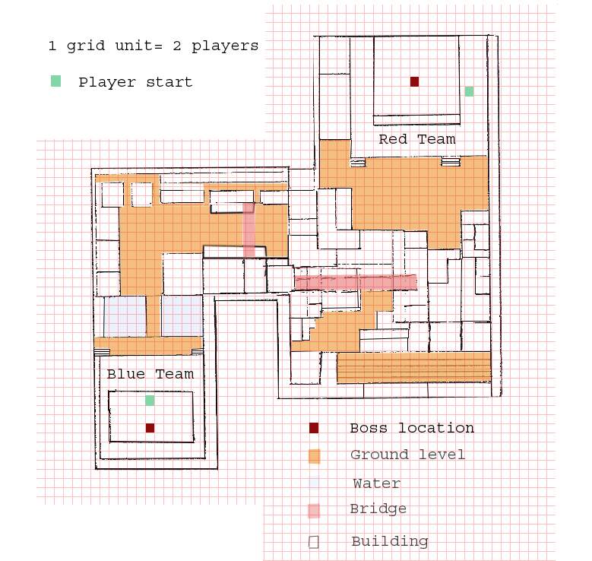

Characters

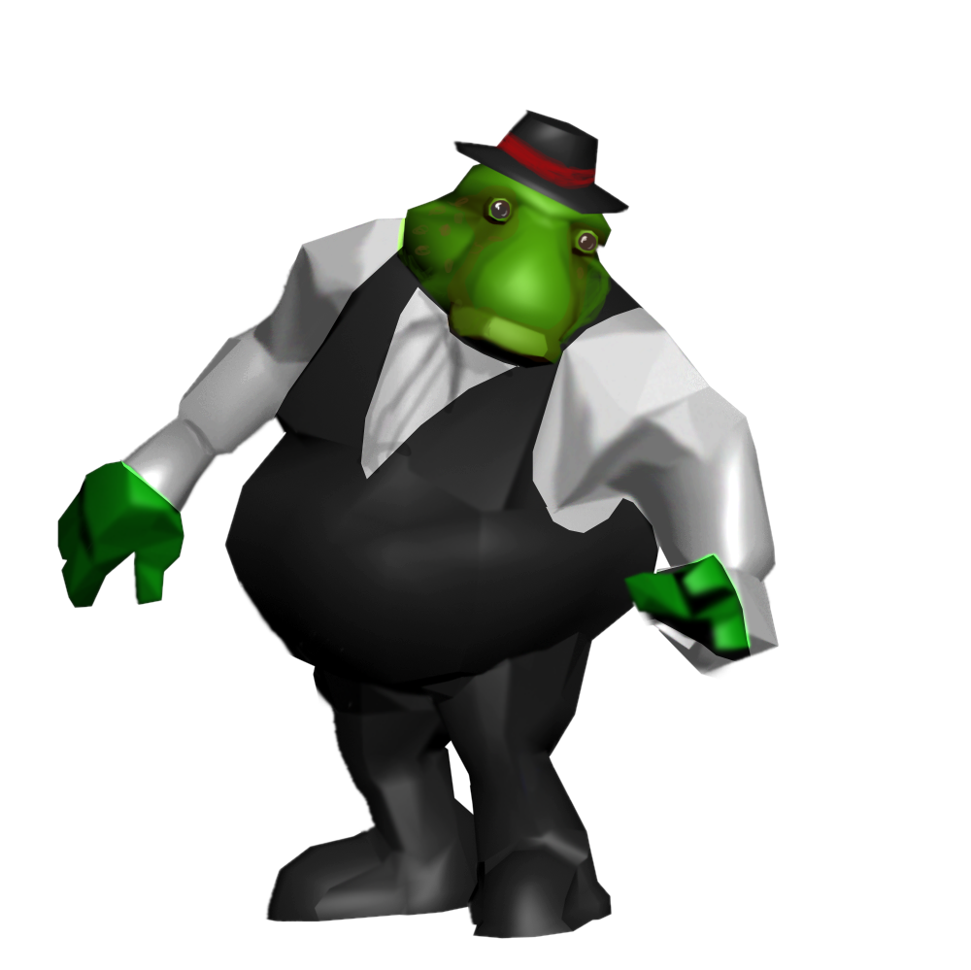
The characters will all be made in 3D Studio Max where they will be rigged, textured and animated before being exported to the Quake III model format.

Halfrunts: The Halfrunts are an oafish race of aliens.
They make up for their lower intelligence with keen
street smarts and powerful brute strength. Having
come to the planet of Allupato to claim it as their
own, they were quickly absorbed into the culture
and decided total invasion was not necessary.
Instead they keep a high population on the
planet to defend the turf that they have
claimed and also defend their honor in
the Evitare arena.

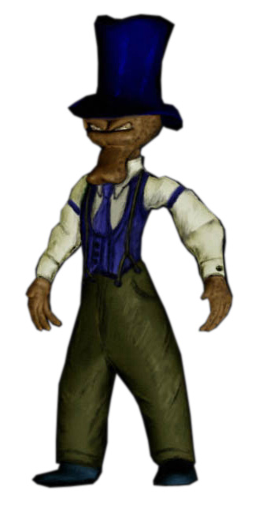

Zaphods: Zaphods are very intelligent aliens.
They are skinny by stature and have incredible eye-sight.
Their biggest flaw is their taste for the forbidden.
Always wanting what they cannot have has put them
into a war with the Halfrunts in the city.
They too are fans of the planet’s most popular sport
Evitare and are fierce competitors.

Weapons

The weapons are basically the same for both games. There are some key differences though.

Conk Launcher:
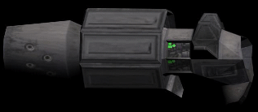
The Conk Launcher is an ingenious device brought about through major advances in technology on Allupato. The carrier of this weapon uses it to violently blast their opponents into the air. Note – The launcher can propel the player firing it in the sports arena of Evitare

Tommy Gun:
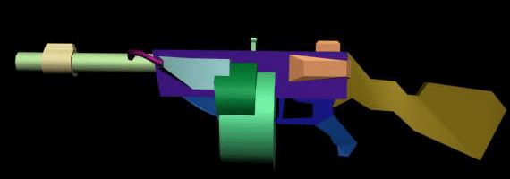
Having a huge infatuation with 1920’s Americana, where would Allupato be without a Tommy Gun? The Tommy Gun is the deadly weapon of choice for the Halfrunts in their Cazzata war against the Zaphods. The Tommy Gun used in the game of Evitare has been rigged to shoot ice crystals at opponents and eventually freeze them.

Sniper Rifle:
Having keen eye site and defensive minds, the Zaphods prefer to take their targets out from a distance. Their weapon of choice is the Sniper Rifle. They have modified it so that it can take up a charge; the longer the charge, the more devastating the hit. The Sniper Rifle has been banned for all Evitare play.
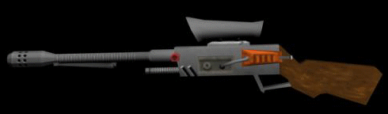

Conk Gun:
The Zaphods do not like short range weapons at all, but decided they needed a defensive weapon in close combat. They created the Conk Gun to help them blast oncoming enemies away far away from them so that they can line up a shot and take them out at distance. It was also discovered that the Conk Gun is very useful at getting the Zaphods to high sniping perches in a fast and safe manner. The Conk Gun has been banned from Evitare.

Gauntlet:
The Gauntlet is a device used in Evitare. Players use it to injure their opponents in a melee attack. Players also use it to thaw out any frozen teammates. One hit takes off three seconds of freeze time.

Shotgun:
The Shotgun is used in the game of Evitare much like the Tommy Gun is used. It shoots ice crystals that, after an opponent has been weakened enough, freeze their opponent, setting him up to be shrunken by a ball.

Ball Launcher:
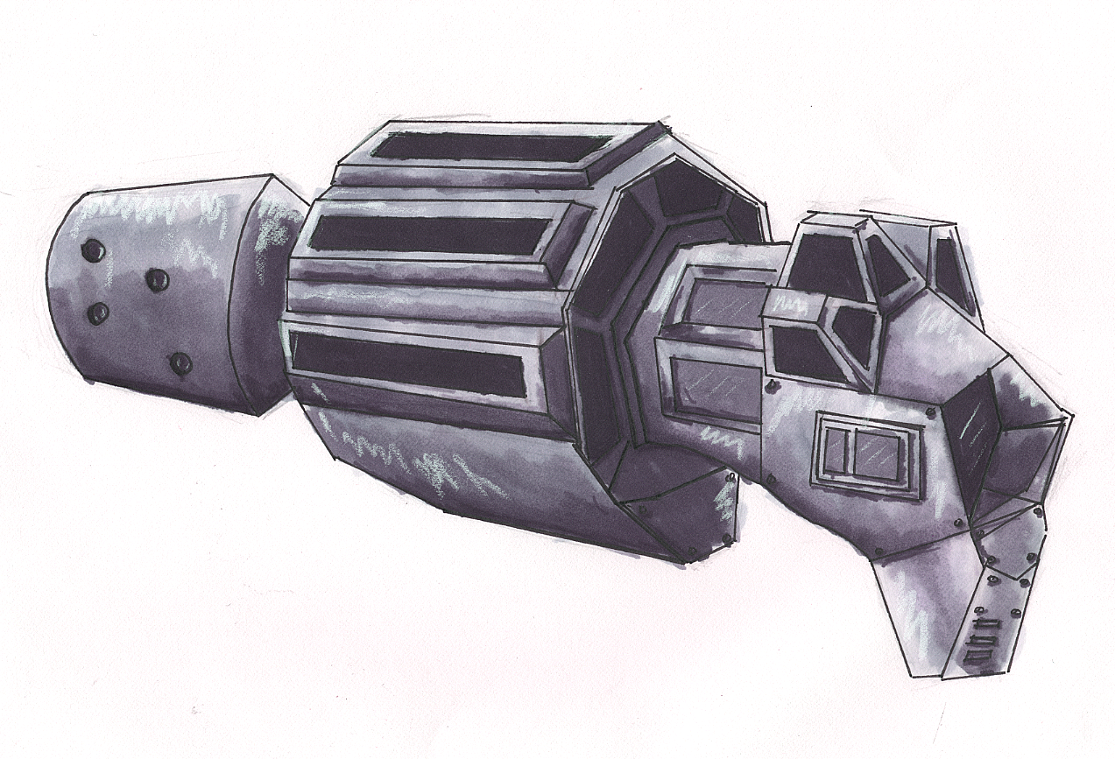
The Ball Launcher is the focus of the game of Evitare. Only a player with a Ball Launcher can carry a ball. With that ball they can then shrink any frozen opponents, thaw out any frozen allies, or pass the ball to an ally carrying a Ball Launcher as well.

Music and Sound Effects

The music will be Quake III’s background music. The sounds in the game will be the sounds effects originally found in Quake III.

Target Audience
The core audience for both Guerra mods is quite diverse. First off Guerra will appeal to males of age 15 to age 35. Both mods will also target fans of science fiction as well as fans of mafia related books and movies. The Evitare mod will also appeal to sports fans, while the Cazzata mod will attract more traditional strategy-based FPS players. People interested in the mod can keep up-to-date with the progress of it by going to the website. It is located at: http://www.binaryc.com/guerra.

Marketing
NVL will be providing plenty of resources for a marketing department. The humor inherint in the style of this game will be a great asset to any ad campaign. There is an abundance of concept art and work in progress available for any special editions and promotions. NVL is also very open to being interviewed and contacted by the game industry media.

Technical Specifications

Code Assets
The Quake III Arena 1.32 source code is the code base that will be expanded upon. The lighting, model loading, level loading, and engine rendering code will remain unchanged. Two new game types, five new weapon behaviors, player bounding box changes, minor AI modifications, and new ball physics are necessary in order to complete Guerra. The total time to complete the programming portion of this project is estimated to be close to 500 man hours.

AI
Not many changes are needed to the bots overall in Quake III. When in the Evitare game type, the bots have been upradged somewhat to pick up the balls on the map instead of viewing them as obstacles to avoid. In the Cazzata game type the bots who play the ‘Dons’ are restricted to specially made bot rooms that hold them in place.

Tools Used
The following tools and software are required for developing the code aspects of the game: four copies of Microsoft Visual C++ .NET, Microsoft Visual SourceSafe 6.0, Q3AGameSource.exe, and the Quake III Arena 1.32 Point Release. Some initial time is also required in order to convert the code assets from the Q3AGameSource.exe into a usable format with Visual C++ .NET. The levels will all be made using the GTK-Radiant 1.2.13 map editor and rendered as BSPs. Existing textures will be modified and new ones will be created using Adobe Photoshop 7 and Corel Painter 5. Models will be created using 3D Studio Max 5 and exported into the Quake III MD3 model format.

System Requirements
The minimum system requirements for Quake III Arena are listed below. Guerra requires that the Quake III Arena 1.32 (or later) Point Release also be installed. It can be found at http://www.idsoftware.com/ and downloaded for free.

Minimum System Requirements – PC.
  - 3-D Hardware Accelerator with full OpenGL® support
  - Pentium II® 300 Mhz or AMD® 350 Mhz K6®-2 processor or Athlon® processor
  - Windows 95/98/ME/NT 4.0/2000 operating system
  - 64 MB RAM
  - 16 MB video card
  - 440 MB of uncompressed hard disk space for each game
  - 110MB of free hard drive space for the Windows swap file (in addition to install space)
  - A 100% Windows® 95/98/ME/NT 4.0/2000-compatible computer system (including compatible 32-bit drivers for CD-ROM drive , video card, sound card and input devices)
  - 100% DirectX 3.0 or higher compatible sound card
  - 100% Microsoft-compatible mouse and driver
  - Quad-speed CD-ROM drive (600 K/sec. sustained transfer rate)
Multiplayer Requirements.
- Internet (TCP/IP) and LAN (TCP/IP and IPX) play supported
- Internet play requires a 100% Windows 95/98/ME/NT 4.0/2000-compatible 28.8 Kbps (or faster) modem

Minimum System Requirements – MAC.

- 3D-accelerated PCI or AGP video card w/ at least 16MB VRAM and Apple® OpenGL® version 1.1.2 (or higher) support
- Apple G3-350 MHz
- OS Version 9.0.4 or higher (excluding Mac® OS X) Operating System
- 64 MB RAM
- 16MB video card
- 440MB of uncompressed hard disk space for each game
- 240MB Virtual Memory
- Quad-speed CD-ROM drive (600K/sec. sustained transfer rate)

Asset List

Art Assets

Characters
Halfrunt – 2 3D models
1 Animation Cycle modified from existing Quake III .bip
3 sets of Textures for Models

Zaphod 2 3D models
1 Animation Cycle modified from existing Quake III .bip
3 sets of Textures for Models

Environments / World Objects

3D Level Objects
Sculptures
Streetlights
Mansion Wall Lights
Awnings
Tubes
Hanging wires
Girders

Environmental Textures
apartments Outside
awnings
bar
Bridges
ceiling textures
Church textures
digital ads
floor textures
Girders
Hanging wires
hover car
Inside doors
Inside wall textures
light pole
liquor store
man hole covers
Mansion Areas
Mansion Wall Lights
Metal grated floors
Metal Walls
nvl logo
outside wall textures
pool tiles
roof tiles
rooftops
Sculptures
Stone columns/railing/steps
store fronts
Streetlights
tapestries
Tubes
wall lights
xxx store

Weapons
Ball -3D model, texture
Tommy gun -3D model, texture
Sniper Rifle -3D model, texture
Conk Launcher -3D model, texture
Conk Gun -3D model, texture

Development Plan

Documentation:
Start: 10/15/03 Finish: 11/21/03

Concept Doc – Brian & Nick
Start: 10/15/03 Finish: 10/20/03

Asset And Dev Plan – Keith & Mike
Start: 10/25/03 Finish: 11/3/03

Design Doc – Kevin & Jon
Start: 11/1/03 Finish: 11/21/03

Level Design Doc - John
Start: 10/16/03 Finish: 10/22/03

Art Development Plan:
Start: 10/3/03 Finish: 12/9/03

Keith & Kevin
Weapon Art
Start: 10/3/03 Finish: 10/18/03

Weapon Concept Art
Start: 10/3/03 Finish: 10/6/03

Weapon Model
Start: 10/7/03 Finish: 10/13/03

Weapon Texture
Start: 10/14/03 Finish: 10/18/03

Character Art
Start: 10/16/03 Finish: 12/9/03

Character Concept Art
Start: 10/16/03 Finish: 10/20/03

Character Model
Start: 10/29/03 Finish: 11/7/03

Character Texture
Start: 11/24/03 Finish: 12/1/03
Character Rigging
Start: 11/31/03 Finish: 12/8/03

Character Animation Applied
Start: 12/2/03 Finish: 12/9/03

Environment Art
Start: 11/8/03 Finish: 11/23/03

Environmental Concept Art
Start: 11/8/03 Finish: 11/14/03

50 Environment Textures
Start: 11/14/03 Finish: 11/23/03

Level Design Development Plan:
Start: 10/20/03 Finish 12/18/03

John B.
Basic Geometry Blocked Out
Start: 10/20/03 Finish 11/6/03

Final Layout
Start: 11/7/03 Finish: 11/17/03

Final Textures Fitted
Start: 11/24/03 Finish: 11/28/03

Final Lighting
Start: 11/28/03 Finish: 12/2/03

Triggers and Sound Finished
Start: 12/3/03 Finish: 12/8/03

Play Test and Adjustment
Start: 12/9/03 Finish: 12/18/03

Programming Development Plan:
Start: 10/6/03 Finish: 12/18/03

Brian
Prototype Tommy Gun
Start: 10/13/03 Finish: 10/17/03
Ball Physics / Finished Tommy Gun
Start: 10/6/03 Finish: 10/10/03

Teams / Classes
Start: 10/13/03 Finish: 10/18/03

Pistol (Roscoe)
Start: 10/20/03 Finish: 10/25/03

Testing / Misc.
Start: 10/27/03 Finish: 10/31/03

Ball Camera
Start: 11/1/03 Finish: 11/7/03

UI
Start: 11/8/03 Finish: 11/13/03

Testing / Misc.
Start: 11/14/03 Finish: 11/20/03

Finish
Start: 12/6/03 Finish: 12/14/03

Jon
Prototype Conk Launcher
Start: 10/6/03 Finish: 10/17/03

Finish Conk Launcher / R&D
Start: 10/13/03 Finish: 10/21/03

Make People Shrink When Hit
Start: 10/23/03 Finish: 10/28/03

Shotgun (Shotty)
Start: 11/5/03 Finish: 11/11/03

Testing / Misc.
Start: 11/12/03 Finish: 11/18/03

Frozen Camera / Small Camera
Start: 11/19/03 Finish: 11/25/03

UI
Start: 11/26/03 Finish: 12/2/03

Testing / Misc.
Start: 12/3/03 Finish: 12/9/03

Finished
Start: 12/10/03 Finish: 12/18/03

Nick
Develop Conk Gun
Start: 10/8/03 Finish: 10/15/03

Program Don Bots Into Game
Start: 10/17/03 Finish: 10/22/03

Force Don Bots to Join Different Teams / AI
Start: 10/23/03 Finish: 10/28/03

New Game Physics
Start: 10/30/03 Finish: 11/5/03

Program Bot Spawn Information
Start: 11/7/03 Finish: 11/12/03

Program Don Death Detection
Start: 11/13/03 Finish: 11/21/03

Polish Game Logic For Alpha
Start: 11/23/03 Finish: 11/24/03

UI
Start: 11/26/03 Finish: 12/4/03

Beta Test
Start: 12/8/03 Finish: 12/17/03

Mike
Create Sniper Rifle Prototype
Start: 10/8/03 Finish: 10/17/03

Integrate Conk Gun and Sniper Rifle Prototype
Start: 10/16/03 Finish: 10/20/03

Disable Friendly Fire
Start: 11/1/03 Finish: 11/7/03

Change Team Names
Start: 11/7/03 Finish: 11/11/03

Disable All Old Quake III Weapons
Start: 11/11/03 Finish: 11/14/03

Give Weapons Out Properly On Spawn
Start: 11/11/03 Finish: 11/14/03

Add Team Switching
Start: 11/14/03 Finish: 11/24/03

Re-work Sniper Rifle Charging Up
Start: 11/17/03 Finish: 11/25/03

Integrate Conk Launcher And Tommy Gun
Start: 11/18/03 Finish: 11/25/03

Implement New UI
Start: 11/25/03 Finish: 12/4/03

Polish
Start: 11/28/03 Finish: 12/12/03

Add Server Configurable Variables
Start: 12/2/03 Finish: 12/9/03

Beta Test
Start: 12/8/03 Finish: 12/17/03

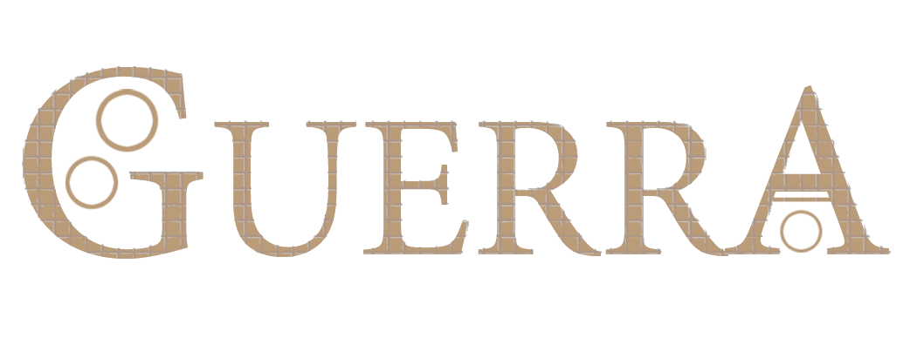

Legal

All applicable material is copyrighted and protected by the Guildhall at SMU (http://guildhall.smu.edu/). Everything else is copyrighted by NVL.

